

CyberShield 360: Design and Analysis of an AI-Enabled Enterprise Cybersecurity Platform
Submitted in the partial fulfilment for the Course of

CSA1012 – Software Engineering

to the award of the degree of

BACHELOR OF TECHNOLOGY

Submitted by
P.Sai Surya Tej (192572044)

UNDER THE SUPERVISION OF
Dr. K. Anita Davamani

SIMATS ENGINEERING
Saveetha Institute of Medical and Technical Sciences
Chennai-602105
July-2026

ACKNOWLEDGEMENT

We would like to express our heartfelt gratitude to all those who supported and guided us throughout the successful completion of our Capstone Project. We are deeply thankful to our respected Founder and Chancellor, Dr. N.M. Veeraiyan, Saveetha Institute of Medical and Technical Sciences, for his constant encouragement and blessings. We also express our sincere thanks to our Pro-Chancellor, Dr. Deepak Nallaswamy Veeraiyan, and our Vice-Chancellor, Dr. S. Suresh Kumar, for their visionary leadership and moral support during the course of this project.

We are truly grateful to our Director, Dr. Ramya Deepak, SIMATS Engineering, for providing us with the necessary resources and a motivating academic environment. Our special thanks to our Principal, Dr. B. Ramesh for granting us access to the institute’s facilities and encouraging us throughout the process. We sincerely thank our Head of the Department, Dr K. Anita Davamani for his continuous support, valuable guidance, and constant motivation.

We are especially indebted to our guide Dr K. Anita Davamani for his creative suggestions, consistent feedback, and unwavering support during each stage of the project. We also express our gratitude to the Project Coordinators, Review Panel Members (Internal and External), and the entire faculty team for their constructive feedback and valuable inputs that helped improve the quality of our work. Finally, we thank all faculty members, lab technicians, our parents, and friends for their continuous encouragement and support.

Signature With Student Name
P. Sai Surya Tej (192572044)

Abstract

The rapid growth of digital transformation, cloud computing, and interconnected enterprise systems has significantly increased the complexity and frequency of cyber threats. Traditional cybersecurity solutions, which primarily rely on signature-based detection and manual analysis, are no longer sufficient to identify sophisticated attacks such as ransomware, phishing, insider threats, Advanced Persistent Threats (APTs), and zero-day vulnerabilities. Enterprise Security Operations Centers (SOCs) face the challenge of analyzing massive volumes of security logs generated from networks, endpoints, cloud platforms, and applications, resulting in delayed incident detection, fragmented visibility, and slower response times.
This case study presents CyberShield 360, an AI-powered Enterprise Cybersecurity Monitoring and Threat Intelligence System designed to enhance organizational security through intelligent automation and real-time threat detection. The proposed platform integrates Artificial Intelligence (AI), Machine Learning (ML), behavioral analytics, and global threat intelligence feeds to continuously monitor enterprise infrastructure, detect anomalous activities, predict potential cyber threats, and automate incident response. By correlating security events from multiple sources, the system minimizes false positives, improves threat visibility, and enables proactive security management.
The proposed solution follows software engineering principles such as modularity, scalability, maintainability, reliability, usability, and security to ensure the development of a robust and enterprise-ready cybersecurity platform. An Agile Scrum development methodology integrated with DevSecOps practices is recommended to support continuous development, rapid deployment, and evolving security requirements. The platform includes modules for data collection, AI-based threat detection, threat intelligence integration, automated response, compliance management, and interactive security dashboards.
The expected outcomes of CyberShield 360 include faster threat detection, reduced incident response time, improved regulatory compliance, enhanced protection against advanced cyberattacks, and greater operational efficiency for security teams. Although challenges such as implementation cost, AI model maintenance, legacy system integration, and privacy concerns remain, the proposed platform provides a scalable and intelligent approach to strengthening enterprise cybersecurity. Overall, CyberShield 360 demonstrates how AI-driven technologies and software engineering practices can be combined to build a modern, resilient, and proactive cybersecurity solution capable of addressing the evolving threat landscape.

Table of Contents
Code of Conduct — Academic Integrity Declaration 2
Table of Contents 3
1. Introduction 5
2. Document Objective 5
3. Scope of Testing 5
4. System Overview 5
5. System Actors 6
6. Functional Requirements 7
7. Non-Functional Requirements 8
8. Test Levels 9
9. Test Scenarios 10
Authentication & Authorization 10
Monitoring 10
Threat Detection 11
Threat Intelligence 11
AI/ML 11
Incident Management 12
Automated Response 12
Dashboard & Reporting 12
Security 12
Reliability & Recovery 13
10. Test Design Techniques 13
10.1 Equivalence Partitioning 13
10.2 Boundary Value Analysis 13
10.3 Decision Table Testing 14
10.4 State Transition Testing 14
11. Detailed Test Cases 15
11.1 Full Test Case Table 17
12. Security Testing 28
13. AI/ML Model Testing 28
14. Performance Testing 29
15. Reliability and Recovery Testing 29
16. Usability Testing 30
17. Test Data 30
18. Traceability Matrix 30
19. Test Coverage Analysis 32
20. Risk-Based Testing 33
21. Defect Severity and Priority 33
Severity Levels 33
Priority Levels 34
22. Entry and Exit Criteria 34
Entry Criteria 34
Exit Criteria 34
23. Test Environment 34
24. Sample Defect Reports 35
Sample Defect: DEF-001 (sample/hypothetical) — Invalid incident state transition not rejected 35
Sample Defect: DEF-002 (sample/hypothetical) — Automated response executes on Critical asset without approval 35
Sample Defect: DEF-003 (sample/hypothetical) — Sensitive log field visible to low-privilege role 36
25. Test Execution Summary 36
26. Ethics and Responsible AI 36
27. Quality Assurance and DevOps Connection 37
28. Conclusion 38
29. References 38
30. Appendices 38
Appendix A — Traceability Flow 38
Appendix B — Glossary of Abbreviations 38

1. Introduction
This document presents a comprehensive test strategy and detailed test case design for CyberShield 360, an AI-Based Enterprise Cybersecurity Monitoring and Threat Intelligence System, prepared as part of CO4 Assessment Tool 1 for the Software Engineering course (CSA10 / CSA1063) at SIMATS Engineering.
The document demonstrates the application of systematic software testing principles — spanning functional correctness, non-functional quality, security, reliability, AI/ML model behaviour, and ethical automation — to a realistic enterprise cybersecurity platform.

2. Document Objective
This document provides a comprehensive test strategy and test case design for CyberShield 360. It demonstrates coverage of:
- Functional correctness across monitoring, detection, intelligence, and response modules
- Non-functional quality: performance, scalability, availability, reliability, usability
- Security: authentication, authorization, input validation, audit logging
- Reliability: failure handling, recovery, and business continuity
- AI/ML model behaviour: accuracy, explainability, bias, drift, and confidence handling
- Threat intelligence integration and correlation
- Incident detection, prioritization, and lifecycle management
- Automated incident response with human-oversight controls
- Dashboard, analytics, and reporting functionality
- Compliance considerations and data integrity
- Ethical AI behaviour and responsible automation

CO4 Alignment: All testing activities described in this document are explicitly mapped to CO4: “Implement robust testing, quality assurance, and DevOps practices, emphasizing security, reliability, and ethics.”

3. Scope of Testing
The scope covers black-box functional and non-functional testing of CyberShield 360 based strictly on the supplied problem statement. Implementation-specific details not present in the problem statement (programming language, database engine, cloud provider, ML framework, specific APIs) are explicitly treated as labelled assumptions where required for test design, and are never presented as confirmed facts.

4. System Overview
CyberShield 360 is defined by the assigned problem statement as an “AI-Based Enterprise Cybersecurity Monitoring and Threat Intelligence System.” The system's major capabilities, as derived strictly from the problem statement, are summarized below.
● Continuous monitoring of enterprise infrastructure ● Network traffic monitoring
● Endpoint monitoring ● Cloud resource monitoring
● User activity monitoring ● Security log collection
● AI/ML-based threat detection ● Malware detection
● Phishing detection ● Ransomware detection
● Insider-threat detection ● Anomaly detection
● Behavioral analysis ● Threat prediction
● Threat intelligence integration ● Risk assessment
● Incident prioritization ● Automated incident response
● Security dashboards ● Security analytics
● Compliance support ● Business continuity
● Detection of advanced persistent threats ● Support for zero-day threat identification
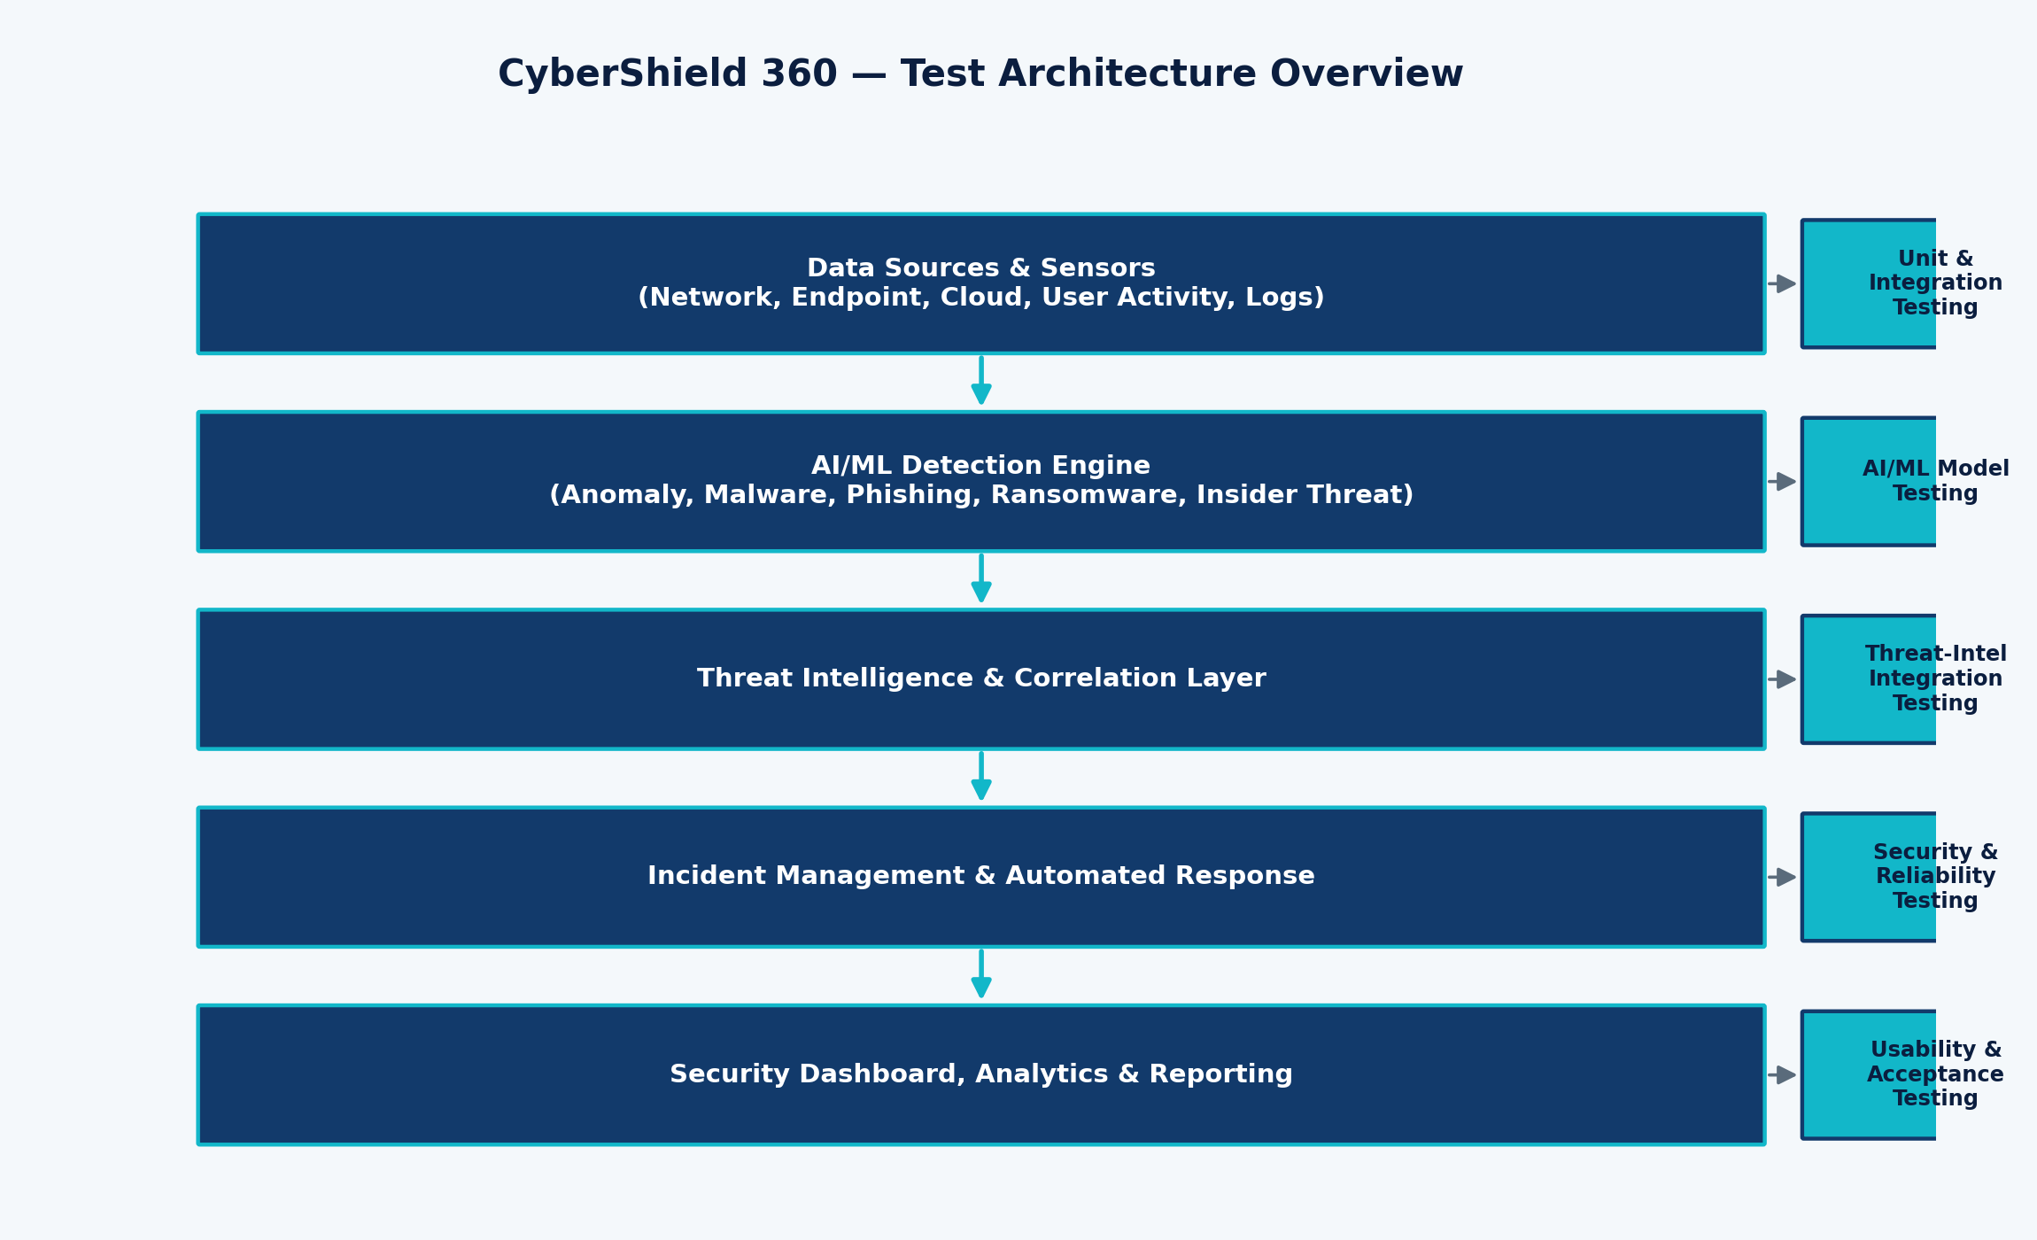
Figure 1: CyberShield 360 Test Architecture Overview
Note: Implementation details such as specific programming languages, database engines, cloud providers, ML frameworks, or third-party APIs are not defined in the problem statement. Where such details are needed for test design, they are explicitly labelled as Assumptions throughout this document.

5. System Actors
The following actors interact with CyberShield 360:
Actor | Responsibility
Security Administrator | Configures system policies, manages users/roles, oversees overall security posture
Security Analyst | Investigates alerts, validates detections, manages incident lifecycle, initiates manual response
Incident Response Team | Executes containment/remediation actions for escalated high-severity incidents
Enterprise User | Generates monitored activity (network, endpoint, cloud, application usage) as a data source
System Administrator | Maintains infrastructure, agents, integrations, and system availability
Threat Intelligence Provider | External source supplying indicators of compromise and threat feeds
AI/ML Detection Engine | Automated component performing anomaly, malware, phishing, and behavioral detection
Monitoring Agent | Lightweight collector deployed on endpoints/network to gather telemetry
Enterprise Infrastructure | Network, endpoints, and cloud resources being monitored
External Security Systems | Third-party SIEM/SOAR/firewall systems that may integrate with CyberShield 360

6. Functional Requirements
The following functional requirements (FR) were derived from the CyberShield 360 problem statement, each assigned a unique ID, priority, testability rating, and related module.
ID | Requirement Description | Priority | Testability | Module
FR-01 | User authentication (username/password, MFA support) for all system users | High | High | Authentication
FR-02 | Role-based access control distinguishing Security Admin, Analyst, and Enterprise User privileges | High | High | Authentication
FR-03 | Continuous monitoring of enterprise network traffic for suspicious patterns | High | High | Monitoring
FR-04 | Continuous monitoring of endpoint devices (workstations, servers) for malicious activity | High | High | Monitoring
FR-05 | Monitoring of cloud resources (storage, compute, IAM events) for misconfigurations and threats | High | Medium | Monitoring
FR-06 | Monitoring of user activity for policy violations and abnormal access patterns | Medium | High | Monitoring
FR-07 | Collection and normalization of security logs from heterogeneous sources | High | High | Monitoring
FR-08 | Real-time processing of ingested security events with minimal latency | High | Medium | Monitoring
FR-09 | AI/ML-based detection of general security threats across monitored assets | High | High | Threat Detection
FR-10 | Detection of malware signatures and malware-like behavior | High | High | Threat Detection
FR-11 | Detection of phishing attempts in email/web traffic indicators | High | High | Threat Detection
FR-12 | Detection of ransomware behavior patterns (mass encryption, rapid file rename) | High | High | Threat Detection
FR-13 | Detection of insider-threat behavior through user behavioral baselining | Medium | Medium | Threat Detection
FR-14 | Statistical and ML-based anomaly detection across network and user activity | High | High | Threat Detection
FR-15 | Behavioral analysis correlating multi-source signals into a single behavior profile | Medium | Medium | Threat Detection
FR-16 | Threat prediction using historical and streaming data trends | Medium | Low | Threat Detection
FR-17 | Ingestion of external threat intelligence feeds (indicators of compromise) | High | High | Threat Intelligence
FR-18 | Correlation of internal events against ingested threat intelligence indicators | High | High | Threat Intelligence
FR-19 | Risk scoring of detected events based on severity, asset criticality, and confidence | High | High | Threat Intelligence
FR-20 | Automatic creation of security incidents from qualifying detections | High | High | Incident Management
FR-21 | Prioritization of incidents based on computed risk score and business impact | High | High | Incident Management
FR-22 | Automated response actions (e.g., endpoint isolation, account suspension) for qualifying incidents | High | Medium | Automated Response
FR-23 | Manual response actions initiated by a Security Analyst or Incident Response Team | High | High | Automated Response
FR-24 | Real-time dashboard visualization of security posture and active threats | High | High | Dashboard & Reporting
FR-25 | Security analytics providing historical trend and pattern views | Medium | Medium | Dashboard & Reporting
FR-26 | Alert and notification generation to relevant stakeholders | High | High | Dashboard & Reporting
FR-27 | Incident investigation workspace with drill-down into evidence | Medium | Medium | Dashboard & Reporting
FR-28 | Generation and export of security and compliance reports | Medium | High | Dashboard & Reporting
FR-29 | Audit logging of all system, analyst, and automated actions | High | High | Compliance
FR-30 | Compliance monitoring support against configurable policy baselines | Medium | Medium | Compliance
FR-31 | Data integrity assurance for collected logs and generated incidents | High | Medium | Data Integrity
FR-32 | System recovery and state restoration after service interruption | High | Medium | Reliability

7. Non-Functional Requirements
The following non-functional requirements (NFR) define quality attributes for CyberShield 360, with testable acceptance criteria wherever reasonable.
ID | Category | Acceptance Criteria
NFR-01 | Performance | Dashboard and alert-critical operations should return within an assumed acceptable response window under normal load.
NFR-02 | Scalability | System should sustain increasing event-ingestion volume without functional degradation, verified via assumed step-load levels.
NFR-03 | Availability | Core monitoring and alerting functions should remain available; failover behavior must be verified for critical services.
NFR-04 | Reliability | System should consistently produce correct detections and incident records across repeated identical inputs.
NFR-05 | Security | System must protect against unauthorized access, injection, and privilege escalation across all interfaces.
NFR-06 | Usability | Dashboard and investigation workflows should be navigable by a Security Analyst without extensive retraining.
NFR-07 | Maintainability | Detection rules and ML models should be updatable without full system downtime (assumption: modular deployment).
NFR-08 | Compatibility | Log ingestion should support commonly assumed formats (syslog, JSON, CEF) from heterogeneous sources.
NFR-09 | Data integrity | Ingested and stored security data must remain unaltered and traceable from source to incident record.
NFR-10 | Fault tolerance | Failure of a single monitoring agent or feed source should not halt overall system operation.
NFR-11 | Auditability | Every automated and manual action must be logged with actor, timestamp, and outcome.
NFR-12 | Privacy | Collected user-activity data should be handled under data-minimization principles appropriate to enterprise monitoring.
NFR-13 | Compliance | System should support alignment with recognized frameworks (e.g., ISO 27001, NIST) as a design consideration, not a certified claim.
NFR-14 | Recovery | System should resume normal operation and reconcile missed events after an outage (assumed recovery objective).
NFR-15 | AI explainability | AI/ML detections should provide an interpretable rationale (e.g., contributing features) to support analyst review.
NFR-16 | AI fairness / bias | Detection models should be evaluated for consistent behavior across user groups and asset types, avoiding systematic bias.
NFR-17 | False-positive control | False-positive rate for high-severity alerts should be minimized through confidence thresholds and correlation.
NFR-18 | False-negative control | Detection logic should be evaluated against known-threat samples to minimize missed detections.
NFR-19 | Secure communication | All data in transit between agents, engine, and dashboard should be encrypted (assumption: TLS).
NFR-20 | Business continuity | Loss of a non-critical component should not interrupt continuous monitoring of critical assets.
Note: Where standards such as ISO 27001, GDPR, or NIST are referenced, they are described as possible compliance considerations rather than claimed certifications, consistent with the problem statement.

8. Test Levels
Test Level | Relevance to CyberShield 360
Unit Testing | Validates individual functions such as risk-score calculation, log parsers, and detection-rule evaluators in isolation.
Integration Testing | Validates interaction between monitoring agents, the AI/ML engine, threat-intelligence connectors, and the incident-management module.
System Testing | Validates end-to-end behaviour from event ingestion through detection, correlation, incident creation, and response.
Regression Testing | Ensures that detection-rule or model updates do not break previously validated functionality.
Performance Testing | Validates system behaviour under normal, peak, and stress event volumes given the real-time monitoring requirement.
Security Testing | Validates authentication, authorization, input handling, and audit logging given the security-critical nature of the platform.
Usability Testing | Validates that Security Analysts can efficiently navigate dashboards and investigation workflows under time pressure.
Acceptance Testing | Validates that the system satisfies the functional and non-functional requirements from a stakeholder perspective.
Reliability Testing | Validates consistent, correct behaviour across repeated runs and failure/recovery scenarios.
AI/ML Model Testing | Validates detection accuracy, confidence handling, explainability, bias, and drift specific to the AI/ML detection engine.

9. Test Scenarios
Test scenarios are grouped by functional category. Each scenario is assigned a unique ID (TS-xx) and later mapped to one or more detailed test cases.

Authentication & Authorization
ID | Scenario
TS-01 | Valid login with correct credentials
TS-02 | Invalid login with incorrect password
TS-03 | Account lockout after repeated failed attempts
TS-04 | Password policy enforcement on account creation/change
TS-05 | Unauthorized access attempt to restricted module
TS-06 | Role-based access restricting Enterprise User from Analyst functions

Monitoring
ID | Scenario
TS-07 | Valid network traffic event ingested and stored
TS-08 | Endpoint monitoring detects new process execution event
TS-09 | Cloud resource monitoring detects IAM configuration change
TS-10 | User activity monitoring logs abnormal file access
TS-11 | Security log collection from multiple heterogeneous sources
TS-12 | Log source becomes unavailable (log loss) mid-collection
TS-13 | Duplicate log entries received from redundant agents
TS-14 | Malformed/corrupted log record submitted to ingestion pipeline

Threat Detection
ID | Scenario
TS-15 | Malware-signature match on endpoint telemetry
TS-16 | Phishing indicator identified in inbound traffic metadata
TS-17 | Ransomware-like mass file-encryption behavior pattern
TS-18 | Insider-threat behavior via abnormal data access outside baseline
TS-19 | Brute-force login behavior against a monitored account
TS-20 | Abnormal login (impossible travel / odd hour) flagged
TS-21 | Data exfiltration pattern (large outbound transfer) flagged
TS-22 | Suspicious process spawning chain on an endpoint
TS-23 | Anomalous network traffic volume/destination flagged
TS-24 | Unknown/zero-day-like behavior with no signature match

Threat Intelligence
ID | Scenario
TS-25 | Valid threat intelligence feed ingested successfully
TS-26 | Invalid/malformed threat intelligence feed rejected
TS-27 | Expired threat intelligence indicator excluded from correlation
TS-28 | Duplicate indicator across two feeds is de-duplicated
TS-29 | Malicious indicator match triggers correlation and incident
TS-30 | Threat intelligence feed source unavailable
TS-31 | Threat intelligence feed delayed beyond expected window
TS-32 | Conflicting threat intelligence from two providers on same indicator

AI/ML
ID | Scenario
TS-33 | Normal behavior correctly classified as non-threat
TS-34 | Anomalous behavior correctly classified as threat
TS-35 | Potential false positive on benign but unusual activity
TS-36 | Potential false negative on subtle malicious activity
TS-37 | AI/ML model service unavailable during detection request
TS-38 | Model response delay exceeding assumed threshold
TS-39 | Detection confidence threshold boundary behavior
TS-40 | Explainability output provided for a high-severity prediction
TS-41 | Model update deployed without disrupting active detections
TS-42 | Concept drift detected via degraded detection accuracy over time

Incident Management
ID | Scenario
TS-43 | Incident automatically created from qualifying detection
TS-44 | Severity correctly assigned based on risk score
TS-45 | Priority correctly assigned considering asset criticality
TS-46 | Incident escalation to Incident Response Team
TS-47 | Incident acknowledgement by assigned analyst
TS-48 | Incident closure after resolution confirmation
TS-49 | Duplicate incident suppressed/merged for same root cause
TS-50 | Incident reassignment to another analyst

Automated Response
ID | Scenario
TS-51 | Automatic blocking of malicious IP/traffic
TS-52 | Automatic endpoint isolation on confirmed malware
TS-53 | Automatic account suspension on confirmed compromise
TS-54 | Alert generation accompanying automated action
TS-55 | Automated response failure is logged and escalated
TS-56 | Partial automated response (one of several steps fails)
TS-57 | Unauthorized/unapproved automated response is blocked

Dashboard & Reporting
ID | Scenario
TS-58 | Real-time dashboard reflects new high-severity threat
TS-59 | Historical analytics view over a selected date range
TS-60 | Filtering incidents by severity/status/asset
TS-61 | Searching incidents by keyword/indicator
TS-62 | Report generation for a compliance review period
TS-63 | Export of report to standard file format
TS-64 | Dashboard shows incomplete/partial data during agent outage

Security
ID | Scenario
TS-65 | Session timeout after period of inactivity
TS-66 | Input validation on analyst-facing search/filter fields
TS-67 | Injection attempt against incident query interface
TS-68 | Privilege escalation attempt by low-privilege role
TS-69 | Data confidentiality of sensitive log fields at rest
TS-70 | Audit log entry created for a manual response action

Reliability & Recovery
ID | Scenario
TS-71 | Network failure between agent and central engine
TS-72 | Threat intelligence outage handled gracefully
TS-73 | Monitoring sensor/agent failure and recovery
TS-74 | Database/service failure and restart
TS-75 | Recovery and event reconciliation after service restart
TS-76 | Backup restoration of incident/log data

10. Test Design Techniques

10.1 Equivalence Partitioning
Input | Valid Partition(s) | Invalid Partition(s)
Login credentials | Well-formed username + correct password | Empty username; correct username + wrong password; SQL-injection payload
User roles | Security Admin, Security Analyst, Incident Response Team, Enterprise User | Undefined/unrecognized role value
Threat severity | Critical, High, Medium, Low | Out-of-range or null severity
Risk score | Integer 0–100 (assumed range) | Negative value; value > 100; non-numeric input
Log input | Well-formed JSON/syslog/CEF record with required fields | Missing required fields; corrupted/non-parseable record
Alert status | New, Acknowledged, In Progress, Resolved, Closed | Undefined status transition value

10.2 Boundary Value Analysis
Boundary values below are tested using Minimum-1, Minimum, and Minimum+1 (or Maximum equivalents) around each threshold. All numeric thresholds are explicitly labelled as assumptions unless defined by the problem statement.
Boundary Field | Tested Values | Purpose
Risk score (alert threshold, assumed 70) | 69 / 70 / 71 | Determines automatic incident creation
Login attempt count (lockout, assumed 5) | 4 / 5 / 6 | Determines account lockout trigger
Log batch size (assumed limit 1000) | 999 / 1000 / 1001 | Determines batch acceptance vs. rejection/splitting
Session timeout (assumed 15 min) | 14 / 15 / 16 minutes | Determines session expiry
Password length (assumed min 8) | 7 / 8 / 9 characters | Determines password acceptance
AI confidence threshold (assumed 0.85) | 0.84 / 0.85 / 0.86 | Determines eligibility for automated response

10.3 Decision Table Testing
Applied to the rule: Threat detected → risk level → confidence → asset criticality → threat-intelligence match → automated-response decision.
Threat Detected? | High Confidence? | High Asset Criticality? | TI Match? | Auto-Response Enabled? | Resulting Action
Yes | Yes | Yes | Yes | Yes | Create incident + Auto block/isolate + Escalate + Notify
Yes | Yes | Yes | Yes | No | Create incident + Request manual approval + Notify
Yes | Yes | No | Yes | Yes | Create incident + Auto block + Raise alert
Yes | Yes | Yes | No | Yes | Create incident + Request manual approval (no TI corroboration)
Yes | No | Yes | Yes | Yes | Create incident + Flag for analyst review (low confidence)
Yes | No | No | No | Yes | Log as low-priority alert only; no incident
No | - | - | - | - | No action; event logged for baseline only

10.4 State Transition Testing
Applied to the Incident Lifecycle: Detected → Created → Triaged → Assigned → Investigating → Contained → Resolved → Closed.
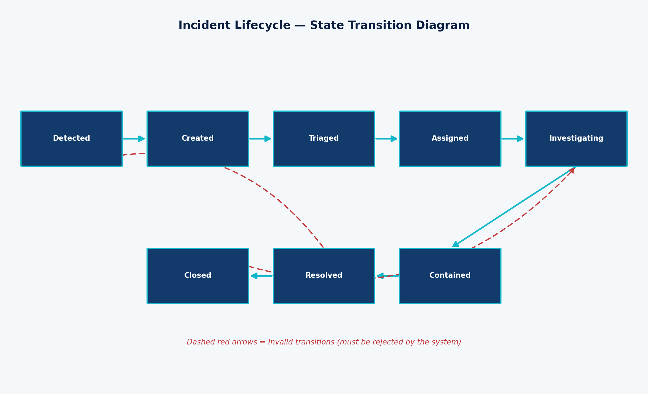
Figure 2: Incident Lifecycle State Transition Diagram (valid transitions in cyan; invalid transitions in dashed red)
Invalid transitions such as Closed → Investigating, Resolved → Detected, and Unassigned → Closed must be explicitly rejected by the system, with the incident remaining in its prior valid state and the rejection recorded in the audit log.

11. Detailed Test Cases
This section contains 70 detailed test cases spanning positive, negative, boundary, security, AI/ML, performance, reliability, usability, and recovery conditions. Actual Result is recorded as “To be filled during execution” and Status as “Not Executed,” as this is a test-design deliverable and the system has not been executed against these cases.
Category | Number of Test Cases
Functional | 16
Negative | 10
Boundary | 7
Security | 8
AI/ML | 9
Performance | 5
Reliability | 6
Usability | 4
Recovery | 5
Total | 70
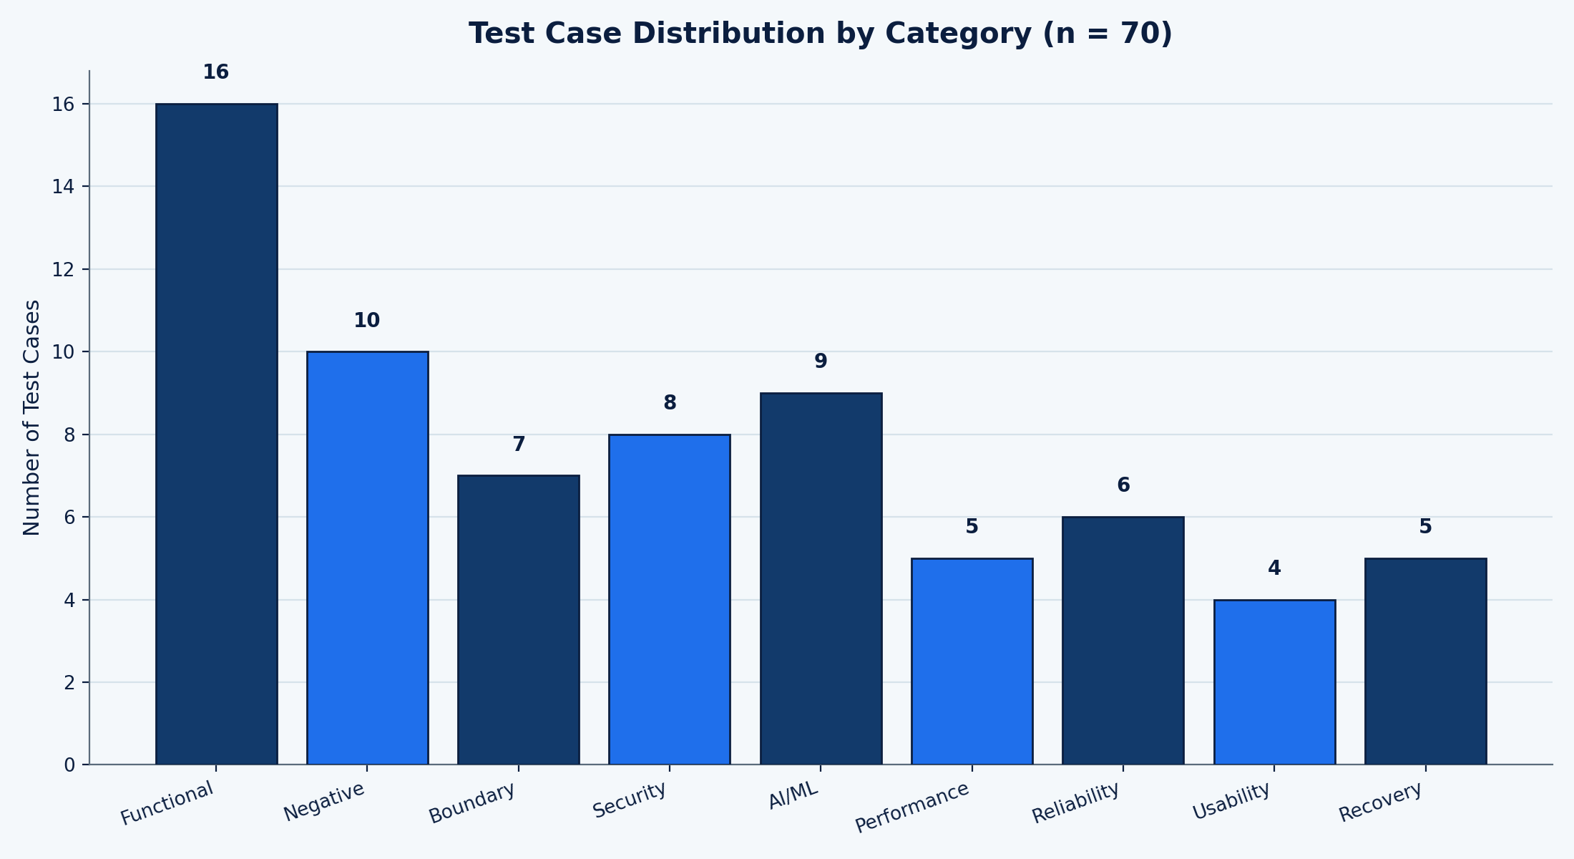
Figure 3: Test Case Distribution by Category (n = 70)

11.1 Full Test Case Table
TC ID | Req ID | TS ID | Module | Test Type | Technique | Scenario | Precondition | Test Steps | Test Data | Expected Result | Actual Result | Status | Priority
TC-AUTH-001 | FR-01 | TS-01 | Authentication | Functional | Equivalence Partitioning | Valid administrator login | Admin account exists and is active | 1. Navigate to the login page  2. Enter valid administrator username and password  3. Click Login | Username: admin_sec01; Password: Valid@Pass123 | User is authenticated and redirected to the Security Dashboard | To be filled during execution | Not Executed | Critical
TC-AUTH-004 | FR-02 | TS-06 | Authentication | Functional | Equivalence Partitioning | Unauthorized role attempting privileged operation | Enterprise User account is logged in | 1. Log in as Enterprise User  2. Attempt to access Incident Response module via direct navigation  3. Attempt to trigger a manual response action | Role: Enterprise User; Target: /incidents/respond | Access is denied with an authorization error; action is not executed and is logged | To be filled during execution | Not Executed | High
TC-MON-001 | FR-03 | TS-07 | Monitoring | Functional | Equivalence Partitioning | Valid network event received | Network monitoring agent is active and connected | 1. Generate a normal outbound HTTP connection from a monitored host  2. Wait for the monitoring pipeline to process the event  3. Check the event store for the corresponding record | Sample event: 10.0.2.15 -> 93.184.216.34:443 | Event is captured, normalized, and stored with correct source, destination, and timestamp | To be filled during execution | Not Executed | High
TC-MON-004 | FR-04 | TS-08 | Monitoring | Functional | Equivalence Partitioning | Endpoint monitoring detects new process execution | Endpoint agent is installed and reporting | 1. Execute a benign new process on the monitored endpoint  2. Allow the agent to report the event  3. Verify event appears in the endpoint activity view | Process: notepad.exe launched by test_user | Process-execution event is logged with process name, parent process, and user context | To be filled during execution | Not Executed | Medium
TC-MON-005 | FR-05 | TS-09 | Monitoring | Functional | Equivalence Partitioning | Cloud IAM configuration change detected | Cloud monitoring integration is configured | 1. Simulate an IAM policy change in the monitored cloud test account  2. Allow the monitoring pipeline to poll/ingest the change  3. Verify the change appears as a monitored event | IAM change: new policy attached to test-role-01 | Configuration-change event is captured with before/after policy state | To be filled during execution | Not Executed | Medium
TC-MON-006 | FR-06 | TS-10 | Monitoring | Functional | Equivalence Partitioning | Abnormal user file access logged | User activity monitoring is enabled for the test account | 1. Access an unusually large number of sensitive files in a short interval as the test user  2. Allow the monitoring pipeline to process activity  3. Verify the activity is logged as a monitored user-activity event | Test user accesses 40 files in 2 minutes (assumed abnormal baseline) | User-activity event is recorded with file count, time window, and user identity | To be filled during execution | Not Executed | Medium
TC-MON-007 | FR-07 | TS-11 | Monitoring | Functional | Equivalence Partitioning | Log collection from multiple sources | At least two distinct log sources (firewall, endpoint) are configured | 1. Generate a log entry from Source A (firewall)  2. Generate a log entry from Source B (endpoint)  3. Verify both are normalized into a common event schema | Source A: firewall syslog; Source B: endpoint agent JSON | Both events are ingested, normalized, and queryable in a unified event store | To be filled during execution | Not Executed | High
TC-MON-008 | FR-08 | TS-07 | Monitoring | Functional | Equivalence Partitioning | Real-time event processing latency | Monitoring pipeline is operating under normal load | 1. Generate a single test event  2. Record the timestamp of generation  3. Record the timestamp the event appears in the dashboard | Single synthetic network event | Event appears in near-real-time processing pipeline within the assumed acceptable latency window (labelled as an assumption) | To be filled during execution | Not Executed | Medium
TC-TD-001 | FR-09 | TS-33 | Threat Detection | Functional | Equivalence Partitioning | Normal user behavior classified as normal | AI/ML detection engine is active with baseline established | 1. Submit a typical, previously-seen benign activity pattern for the test user  2. Allow the detection engine to classify it  3. Check the classification result | Baseline-consistent login and file-access pattern | Event is classified as Normal with no incident created | To be filled during execution | Not Executed | High
TC-AI-002 | FR-14 | TS-34 | Threat Detection | Functional | Equivalence Partitioning | Anomalous user behavior detected | AI/ML detection engine is active with baseline established | 1. Submit an activity pattern that significantly deviates from the established baseline (e.g., login from new geography plus mass download)  2. Allow the detection engine to classify it  3. Check classification and confidence score | Deviant pattern: login from unfamiliar region + 500 file downloads in 5 minutes | Event is classified as Anomalous/Threat with a confidence score above the alerting threshold, and an incident candidate is generated | To be filled during execution | Not Executed | Critical
TC-TI-001 | FR-17 | TS-25 | Threat Intelligence | Functional | Equivalence Partitioning | Valid threat intelligence indicator received | Threat intelligence feed connector is configured | 1. Submit a well-formed indicator (IP/domain/hash) via the test feed  2. Allow ingestion pipeline to process it  3. Verify indicator is stored in the intelligence repository | Indicator: malicious-domain-test.example, type=domain | Indicator is validated, stored, and made available for correlation | To be filled during execution | Not Executed | High
TC-TI-004 | FR-18 | TS-29 | Threat Intelligence | Functional | Equivalence Partitioning | Threat intelligence match triggers correlation | A known-malicious indicator exists in the intelligence repository | 1. Generate a monitored event whose destination matches the stored malicious indicator  2. Allow the correlation engine to process the event  3. Verify correlation result | Outbound connection to malicious-domain-test.example | Event is correlated with the matching indicator and flagged with elevated risk score | To be filled during execution | Not Executed | Critical
TC-INC-001 | FR-20 | TS-43 | Incident Management | Functional | Decision Table | Threat automatically creates incident | A detection with confidence and severity above the automated-incident threshold occurs | 1. Trigger a qualifying high-confidence, high-severity detection  2. Allow the incident engine to evaluate the decision table  3. Verify an incident record is created | Detection: confidence=0.95, severity=High, asset=Critical DB server | A new incident is automatically created, linked to the source detection, with status = Created | To be filled during execution | Not Executed | Critical
TC-INC-002 | FR-21 | TS-44 | Incident Management | Functional | Decision Table | Incident severity correctly assigned | An incident has been created from a qualifying detection | 1. Review the computed risk score for the incident  2. Compare against the severity-mapping table  3. Verify assigned severity | Risk score = 87 (assumed mapping: 80-100 = Critical) | Incident severity is set to Critical, consistent with the defined risk-score mapping | To be filled during execution | Not Executed | High
TC-RESP-001 | FR-22 | TS-52 | Automated Response | Functional | Decision Table | Automatic endpoint isolation | Automated response is enabled and a confirmed malware incident exists on a Medium-or-lower-criticality asset per policy | 1. Trigger a confirmed malware detection on the qualifying endpoint  2. Allow the automated response engine to evaluate policy  3. Verify endpoint isolation action is executed | Confirmed malware on endpoint EP-0231 (non-critical asset) | Endpoint is automatically isolated from the network, action is logged, and an alert is raised to the analyst | To be filled during execution | Not Executed | Critical
TC-DASH-001 | FR-24 | TS-58 | Dashboard & Reporting | Functional | Equivalence Partitioning | Real-time threat displayed on dashboard | A qualifying high-severity incident has just been created | 1. Open the Security Dashboard as a logged-in Analyst  2. Observe the active-threats panel  3. Verify the new incident appears without manual refresh | Newly created Critical-severity incident | Incident appears on the real-time dashboard panel within the assumed refresh interval, with correct severity indicator | To be filled during execution | Not Executed | High
TC-AUTH-002 | FR-01 | TS-02 | Authentication | Negative | Equivalence Partitioning | Invalid password | A valid user account exists | 1. Navigate to the login page  2. Enter a valid username with an incorrect password  3. Click Login | Username: admin_sec01; Password: WrongPass!1 | Login is rejected with a generic authentication-failure message; no session is created | To be filled during execution | Not Executed | High
TC-MON-002 | FR-07 | TS-14 | Monitoring | Negative | Equivalence Partitioning | Malformed security log | Log ingestion pipeline is running | 1. Submit a log entry with an invalid/corrupted schema (missing required fields)  2. Allow the ingestion pipeline to process it  3. Check ingestion pipeline error handling | Malformed record: {"src": null, "event":} | Malformed record is rejected/quarantined, an ingestion error is logged, and the pipeline continues processing subsequent records | To be filled during execution | Not Executed | Medium
TC-TI-002 | FR-17 | TS-26 | Threat Intelligence | Negative | Equivalence Partitioning | Invalid feed rejected | Threat intelligence connector is active | 1. Submit a feed payload with an unsupported/invalid format  2. Allow ingestion pipeline to validate the payload  3. Check rejection handling | Payload: non-JSON garbled text submitted as feed data | Feed is rejected with a validation error; no indicators are added to the repository | To be filled during execution | Not Executed | Medium
TC-TI-002B | FR-18 | TS-30 | Threat Intelligence | Negative | Equivalence Partitioning | Threat intelligence provider unavailable | Primary threat intelligence feed endpoint is reachable under normal conditions | 1. Simulate the feed provider endpoint being unreachable (timeout/connection refused)  2. Trigger a scheduled feed pull  3. Observe system behavior | Feed endpoint returns connection timeout | System logs a feed-unavailable warning, continues operating with existing indicators, and retries per configured policy | To be filled during execution | Not Executed | High
TC-AI-004 | FR-14 | TS-35 | Threat Detection | Negative | Equivalence Partitioning | Potential false positive | AI/ML detection engine is active | 1. Submit a benign but statistically unusual event (e.g., legitimate but rare admin task)  2. Allow the engine to classify the event  3. Review classification and confidence | Legitimate quarterly bulk password reset performed by Security Administrator | Event may be flagged for review but should not auto-trigger a Critical incident without corroborating signals; explainability output should be available for analyst review | To be filled during execution | Not Executed | Medium
TC-AI-005 | FR-14 | TS-36 | Threat Detection | Negative | Equivalence Partitioning | Potential false negative | AI/ML detection engine is active with known-threat sample set | 1. Submit a subtly malicious event designed to resemble benign activity (evasion attempt)  2. Allow the engine to classify the event  3. Compare result against expected ground truth | Slow, low-and-slow data exfiltration mimicking normal traffic patterns | Gap analysis: if the event is missed, it must be captured in model-evaluation records for retraining; test documents actual vs. expected outcome | To be filled during execution | Not Executed | High
TC-SEC-001B | FR-02 | TS-05 | Security | Negative | Equivalence Partitioning | Unauthorized API/function access | A valid but low-privilege session token exists | 1. Attempt to call a privileged incident-response API endpoint directly using the low-privilege token  2. Observe the API response | Endpoint: POST /api/incidents/{id}/isolate; Role: Enterprise User | Request is rejected with HTTP 403 Forbidden; attempt is recorded in the audit log | To be filled during execution | Not Executed | Critical
TC-INC-003 | FR-20 | TS-not-applicable-invalid-transition | Incident Management | Negative | State Transition | Invalid incident state transition | An incident exists in status = Closed | 1. Attempt to transition the incident directly from Closed to Investigating  2. Observe system response | Incident ID: INC-1042; attempted transition: Closed -> Investigating | Transition is rejected as invalid; incident remains in Closed status; rejection is logged | To be filled during execution | Not Executed | Medium
TC-RESP-002 | FR-22 | TS-55 | Automated Response | Negative | Decision Table | Automated response failure | A qualifying incident triggers an automated isolation action, but the target endpoint is offline | 1. Trigger automated endpoint isolation for an incident where the target endpoint is unreachable  2. Observe system handling of the failed action | Target endpoint EP-0987 is powered off / unreachable | Response failure is detected, logged, and the incident is automatically escalated to a human analyst for manual handling | To be filled during execution | Not Executed | High
TC-TI-005 | FR-18 | TS-32 | Threat Intelligence | Negative | Equivalence Partitioning | Conflicting threat intelligence | Two configured providers supply intelligence on overlapping indicators | 1. Ingest an indicator marked 'malicious' from Provider A  2. Ingest the same indicator marked 'benign/whitelisted' from Provider B  3. Verify system handling of the conflict | Indicator: 198.51.100.23 — Provider A: malicious; Provider B: benign | Conflict is flagged for analyst review rather than silently resolved; both source assessments are retained for traceability | To be filled during execution | Not Executed | Medium
TC-BND-001 | FR-19 | TS-39 | Threat Detection | Boundary | Boundary Value Analysis | Risk score boundary — just below alert threshold | Alert threshold is configured at 70 (assumed) | 1. Submit a detection event scored at 69 (threshold-1)  2. Observe whether an incident is auto-created | Risk score = 69 | No automatic incident is created; event is logged as sub-threshold for analyst visibility only | To be filled during execution | Not Executed | Medium
TC-BND-002 | FR-19 | TS-39 | Threat Detection | Boundary | Boundary Value Analysis | Risk score boundary — exactly at threshold | Alert threshold is configured at 70 (assumed) | 1. Submit a detection event scored at exactly 70  2. Observe system behavior | Risk score = 70 | Incident is automatically created, consistent with the 'at or above threshold' rule | To be filled during execution | Not Executed | High
TC-BND-003 | FR-19 | TS-39 | Threat Detection | Boundary | Boundary Value Analysis | Risk score boundary — just above threshold | Alert threshold is configured at 70 (assumed) | 1. Submit a detection event scored at 71 (threshold+1)  2. Observe system behavior | Risk score = 71 | Incident is automatically created with correct severity mapping | To be filled during execution | Not Executed | High
TC-BND-004 | FR-01 | TS-03 | Authentication | Boundary | Boundary Value Analysis | Login attempt count boundary before lockout | Account lockout threshold is configured at 5 failed attempts (assumed) | 1. Perform 4 consecutive failed login attempts  2. Attempt a 5th failed login  3. Attempt a 6th login (even with correct password) | Failed attempts: 5 total, threshold = 5 | Account locks out exactly on/after the 5th failed attempt; the 6th attempt (attempt count+1) is rejected regardless of credential correctness | To be filled during execution | Not Executed | High
TC-BND-005 | FR-01 | TS-04 | Authentication | Boundary | Boundary Value Analysis | Password length boundary | Password policy requires a minimum of 8 characters (assumed) | 1. Attempt to set a password of 7 characters  2. Attempt to set a password of exactly 8 characters  3. Attempt to set a password of 9 characters | Passwords: 'Ab1@xyz' (7), 'Ab1@xyzZ' (8), 'Ab1@xyzZQ' (9) | 7-character password is rejected; 8- and 9-character passwords meeting complexity rules are accepted | To be filled during execution | Not Executed | Medium
TC-BND-006 | FR-08 | TS-07 | Monitoring | Boundary | Boundary Value Analysis | Log batch size boundary | Log ingestion batch size limit is configured at 1000 records (assumed) | 1. Submit a batch of 999 log records  2. Submit a batch of exactly 1000 records  3. Submit a batch of 1001 records | Batch sizes: 999, 1000, 1001 | Batches at or below the limit (999, 1000) are accepted for processing; the 1001-record batch is rejected or split per configured policy, with the condition clearly logged | To be filled during execution | Not Executed | Medium
TC-BND-007 | FR-24 | TS-65 | Dashboard & Reporting | Boundary | Boundary Value Analysis | Session timeout boundary | Session timeout is configured at 15 minutes of inactivity (assumed) | 1. Remain inactive for 14 minutes and perform an action  2. Remain inactive for exactly 15 minutes and attempt an action  3. Remain inactive for 16 minutes and attempt an action | Inactivity intervals: 14, 15, 16 minutes | Session remains valid at 14 minutes; session is expired at/after the 15-minute threshold, requiring re-authentication | To be filled during execution | Not Executed | Medium
TC-SEC-001 | FR-02 | TS-05 | Security | Security | Equivalence Partitioning | Unauthorized API/function access | Low-privilege session exists | 1. Attempt direct URL navigation to an admin-only configuration page  2. Observe system response | URL: /admin/system-config; Role: Enterprise User | Access is denied (HTTP 403) and the attempt is recorded in the audit trail | To be filled during execution | Not Executed | Critical
TC-SEC-002 | FR-27 | TS-67 | Security | Security | Equivalence Partitioning | Malicious input validation | Analyst is logged into the incident investigation search | 1. Enter a SQL-injection-style payload into the incident search field  2. Submit the search  3. Observe system response | Payload: ' OR '1'='1' -- | Input is safely sanitized/parameterized; no unintended data is returned or altered; attempt is logged as a suspicious input event | To be filled during execution | Not Executed | Critical
TC-SEC-003 | FR-02 | TS-68 | Security | Security | Decision Table | Privilege escalation attempt | Analyst-level session exists | 1. Attempt to modify own role/permissions via a crafted API request  2. Observe system response | Request: PATCH /api/users/self {role:'admin'} | Request is rejected; role remains unchanged; escalation attempt is logged and flagged for administrator review | To be filled during execution | Not Executed | Critical
TC-SEC-004 | FR-29 | TS-70 | Security | Security | Equivalence Partitioning | Audit logging of manual response action | Analyst has permission to perform manual response actions | 1. Perform a manual account-suspension action on a test account  2. Review the audit log | Action: suspend account test_user_02 | Audit log contains actor, action, target, timestamp, and outcome for the manual action | To be filled during execution | Not Executed | High
TC-SEC-005 | FR-31 | TS-69 | Security | Security | Equivalence Partitioning | Data confidentiality of sensitive log fields | Logs containing sensitive fields (e.g., partial credentials, PII) are stored | 1. Query the raw log store as a non-privileged role  2. Observe whether sensitive fields are masked or restricted | Log field: user email, partial session token | Sensitive fields are masked or access-restricted for non-privileged roles; only authorized roles can view unmasked values | To be filled during execution | Not Executed | High
TC-SEC-006 | FR-01 | TS-65 | Security | Security | Boundary Value Analysis | Session management — idle timeout enforcement | Analyst session is active | 1. Leave session idle beyond the configured timeout  2. Attempt an action requiring authentication | Idle duration exceeding assumed 15-minute timeout | Session is invalidated; user is redirected to re-authenticate before the action proceeds | To be filled during execution | Not Executed | Medium
TC-SEC-007 | FR-22 | TS-57 | Security | Security | Decision Table | Unauthorized automated response trigger | Automated response engine is active | 1. Attempt to invoke the automated-response API directly without a qualifying detection context  2. Observe system response | Direct call to /api/response/isolate without linked incident ID | Request is rejected due to missing/invalid context; no response action is executed; attempt is logged | To be filled during execution | Not Executed | High
TC-SEC-008 | FR-19 | TS-67 | Security | Security | Equivalence Partitioning | Injection attempt against incident query interface | Analyst is authenticated | 1. Submit a script-injection payload into the incident report title field  2. Save and re-render the report  3. Observe rendered output | Payload: <script>alert(1)</script> | Payload is escaped/sanitized on storage and rendering; no script execution occurs in the dashboard | To be filled during execution | Not Executed | High
TC-AI-001 | FR-09 | TS-33 | AI/ML | AI/ML | Equivalence Partitioning | Normal user behavior classified as normal | Baseline behavioral profile exists for the test user | 1. Submit typical login and resource-access activity consistent with baseline  2. Review classification output | Standard 9am login, routine file access | Classified as Normal with low anomaly score; no incident generated | To be filled during execution | Not Executed | Medium
TC-AI-003 | FR-14 | TS-34 | AI/ML | AI/ML | Equivalence Partitioning | High-confidence malicious behavior detected | Model is loaded and serving predictions | 1. Submit an activity pattern strongly matching a known-malicious profile  2. Review confidence score and classification | Pattern closely matching labelled ransomware precursor behavior | Classified as Threat with confidence score in the high range (assumed >0.9); incident candidate generated | To be filled during execution | Not Executed | Critical
TC-AI-006 | FR-14 | TS-37 | AI/ML | AI/ML | Equivalence Partitioning | Model service unavailable | AI/ML inference service is intentionally stopped for the test | 1. Submit a detection request while the model service is down  2. Observe system fallback behavior | Model endpoint returns 503 Service Unavailable | System logs the failure, falls back to rule-based/heuristic detection where available, and flags reduced-confidence operation without crashing | To be filled during execution | Not Executed | High
TC-AI-007 | FR-14 | TS-38 | AI/ML | AI/ML | Boundary Value Analysis | Model response delay exceeding threshold | Model service is artificially delayed beyond the assumed 5-second SLA | 1. Submit a detection request  2. Measure response time  3. Observe timeout handling | Simulated model latency: 8 seconds (assumed 5s SLA) | Request times out gracefully, is logged as a latency incident, and does not block downstream event processing | To be filled during execution | Not Executed | Medium
TC-AI-008 | FR-19 | TS-39 | AI/ML | AI/ML | Boundary Value Analysis | Detection confidence threshold behavior | Confidence threshold for auto-action is configured at 0.85 (assumed) | 1. Submit an event scored at confidence 0.84  2. Submit an event scored at confidence 0.85  3. Submit an event scored at confidence 0.86 | Confidence scores: 0.84, 0.85, 0.86 | Events below 0.85 are flagged for analyst review only; events at/above 0.85 qualify for automated-response evaluation | To be filled during execution | Not Executed | High
TC-AI-009 | FR-16 | TS-40 | AI/ML | AI/ML | Equivalence Partitioning | Explainability output for high-severity prediction | A high-severity detection has been generated | 1. Open the detection detail view  2. Review the provided explanation/contributing-factors output | High-severity ransomware-pattern detection | System presents a human-readable rationale (e.g., top contributing features/indicators) supporting the classification | To be filled during execution | Not Executed | High
TC-AI-010 | FR-09 | TS-41 | AI/ML | AI/ML | Equivalence Partitioning | Model update without disrupting detections | A model version update is scheduled | 1. Trigger a model version rollout during simulated active monitoring  2. Submit test events during the rollout window  3. Verify detection continuity | Model v1.2 -> v1.3 rollout | Detection service continues operating (via blue-green/rolling assumption) without dropped events; version change is logged | To be filled during execution | Not Executed | Medium
TC-AI-011 | FR-16 | TS-42 | AI/ML | AI/ML | Equivalence Partitioning | Concept drift detection | Historical accuracy baseline is recorded for the model | 1. Submit a labelled evaluation batch reflecting recent traffic patterns  2. Compare current accuracy/precision against baseline  3. Check for drift-alert generation | Evaluation batch showing a measurable accuracy drop versus baseline (assumed threshold: 5 percentage points) | System flags potential concept drift and recommends model retraining/review; does not silently continue degrading | To be filled during execution | Not Executed | Medium
TC-AI-012 | FR-09 | TS-36 | AI/ML | AI/ML | Equivalence Partitioning | Ethical control on high-impact automated action | A detection qualifies for a high-impact action (e.g., critical server isolation) | 1. Trigger a qualifying detection against a Critical-tier asset  2. Observe whether the system executes the action automatically or requests human approval | Detection on Critical-tier production database server | System requires human analyst approval before executing a high-impact automated action on Critical-tier assets, per responsible-AI control design | To be filled during execution | Not Executed | Critical
TC-PERF-001 | FR-08 | TS-07 | Performance | Performance | Equivalence Partitioning | Large-volume security event processing | Test environment configured for load testing | 1. Generate a sustained stream of 10,000 events/minute (assumed load level)  2. Monitor processing pipeline for backlog or drops  3. Record throughput and latency | Synthetic load: 10,000 events/min for 10 minutes | Pipeline sustains the load with no event loss; latency remains within the assumed acceptable range; results are documented, not assumed | To be filled during execution | Not Executed | High
TC-SCAL-001 | FR-08 | TS-07 | Performance | Performance | Equivalence Partitioning | System behavior under increasing event volume | Test environment supports scaled load generation | 1. Incrementally increase event volume from 1x to 5x assumed baseline  2. Observe scaling behavior and resource utilization  3. Identify degradation point if any | Step load: 1x, 2x, 3x, 4x, 5x baseline volume | System scales predictably or degrades gracefully with clear logging; any breaking point is documented as a finding, not a fabricated metric | To be filled during execution | Not Executed | Medium
TC-PERF-002 | FR-24 | TS-58 | Performance | Performance | Equivalence Partitioning | Dashboard refresh under concurrent analyst load | Multiple analyst sessions are simulated | 1. Simulate 20 concurrent analyst sessions viewing the live dashboard  2. Measure dashboard refresh responsiveness | Concurrent sessions: 20 (assumed test level) | Dashboard remains responsive within the assumed acceptable refresh window for all concurrent sessions | To be filled during execution | Not Executed | Medium
TC-PERF-003 | FR-09 | TS-33 | Performance | Performance | Equivalence Partitioning | Threat detection latency under normal load | Detection engine operating under normal event volume | 1. Submit a test detection-triggering event  2. Measure time from ingestion to classification result | Single high-priority test event under normal background load | Detection latency is recorded and compared against the assumed target window; result is reported factually | To be filled during execution | Not Executed | High
TC-PERF-004 | FR-26 | TS-54 | Performance | Performance | Equivalence Partitioning | Alert generation latency | A qualifying incident has just been created | 1. Measure time from incident creation to alert/notification dispatch | Single Critical-severity incident | Alert is dispatched within the assumed acceptable latency window; actual measured value is recorded rather than assumed | To be filled during execution | Not Executed | Medium
TC-REL-001 | FR-32 | TS-73 | Reliability | Reliability | Equivalence Partitioning | Recovery after monitoring service failure | Monitoring service is running normally | 1. Forcibly stop the monitoring service  2. Restart the service after a defined interval  3. Verify service resumes processing and reconciles any queued events | Simulated outage duration: 5 minutes (assumed) | Service restarts cleanly, resumes event processing, and reconciles/backfills events queued during the outage where feasible | To be filled during execution | Not Executed | High
TC-REL-002 | FR-32 | TS-72 | Reliability | Reliability | Equivalence Partitioning | Threat-intelligence outage handled gracefully | Threat intelligence connector is active | 1. Simulate the threat-intelligence provider being unreachable for an extended period  2. Verify system continues monitoring using existing/local indicators | Outage duration: 30 minutes (assumed) | Core monitoring/detection continues using cached indicators; outage is logged; correlation resumes automatically on reconnect | To be filled during execution | Not Executed | Medium
TC-REL-003 | FR-32 | TS-71 | Reliability | Reliability | Equivalence Partitioning | Network failure between agent and central engine | Monitoring agent is actively reporting | 1. Disconnect network connectivity between agent and central engine  2. Reconnect after a defined interval  3. Verify buffered events are transmitted | Simulated disconnect: 3 minutes (assumed) | Agent buffers events locally during the outage (within assumed buffer limits) and forwards them upon reconnection without duplication | To be filled during execution | Not Executed | High
TC-REL-004 | FR-32 | TS-74 | Reliability | Reliability | Equivalence Partitioning | Database/service failure and restart | Backing data store is operational | 1. Simulate abrupt database service termination  2. Restart the database service  3. Verify application reconnects and resumes normal operation | Simulated database restart | Application detects the outage, retries connection per policy, and resumes normal read/write operations without data corruption | To be filled during execution | Not Executed | High
TC-REL-005 | FR-31 | TS-75 | Reliability | Reliability | Equivalence Partitioning | Duplicate event handling after recovery | System has just recovered from a simulated outage | 1. Allow buffered/retransmitted events to be reprocessed post-recovery  2. Verify no duplicate incidents or log entries are created | Overlapping event batch re-sent after reconnect | System applies de-duplication logic; no duplicate incidents or redundant log records are created | To be filled during execution | Not Executed | Medium
TC-REL-006 | FR-32 | TS-76 | Reliability | Reliability | Equivalence Partitioning | Backup restoration of incident/log data | A backup of incident and log data exists from a prior checkpoint | 1. Simulate data-store loss  2. Restore from the most recent backup  3. Verify restored data integrity and completeness | Backup checkpoint from prior day (assumed backup schedule) | Data is restored to the last valid checkpoint with verified integrity; restoration process and any data-gap window are logged | To be filled during execution | Not Executed | High
TC-USE-001 | FR-24 | TS-58 | Usability | Usability | Equivalence Partitioning | Dashboard readability of severity indicators | Dashboard is populated with mixed-severity incidents | 1. Open the dashboard as an Analyst  2. Visually assess whether severity levels are distinguishable at a glance | Mixed set: Critical, High, Medium, Low incidents | Severity levels are clearly distinguishable through color/iconography without requiring the analyst to open each record | To be filled during execution | Not Executed | Low
TC-USE-002 | FR-27 | TS-61 | Usability | Usability | Equivalence Partitioning | Incident search and filtering usability | Multiple incidents exist in the system | 1. Use the search bar to locate an incident by partial keyword  2. Apply a severity filter  3. Verify results update correctly | Search term: partial asset name; Filter: severity=High | Search and filter return accurate, correctly narrowed results without requiring page reload | To be filled during execution | Not Executed | Medium
TC-USE-003 | FR-28 | TS-62 | Usability | Usability | Equivalence Partitioning | Report generation workflow clarity | Analyst has reporting permissions | 1. Navigate to the reporting module  2. Generate a report for a selected date range  3. Verify the workflow is completable without external guidance | Report period: last 30 days | Report is generated through a clear, guided workflow with appropriate progress indication and no ambiguous steps | To be filled during execution | Not Executed | Low
TC-USE-004 | FR-26 | TS-58 | Usability | Usability | Equivalence Partitioning | Error-message clarity on failed action | Analyst attempts an action that will fail validation | 1. Submit an incident update with a required field left blank  2. Observe the resulting error message | Incident update missing 'resolution notes' | A clear, specific error message identifies the missing field, rather than a generic failure notice | To be filled during execution | Not Executed | Low
TC-RCV-001 | FR-32 | TS-73 | Recovery | Recovery | Equivalence Partitioning | Sensor failure and recovery | Monitoring sensor is active | 1. Simulate sensor process crash  2. Allow automatic restart/watchdog to trigger (assumed capability)  3. Verify sensor resumes reporting | Simulated crash of endpoint agent process | Sensor restarts automatically or is flagged for administrator attention if auto-restart is not supported; downtime window is logged | To be filled during execution | Not Executed | High
TC-RCV-002 | FR-31 | TS-75 | Recovery | Recovery | Equivalence Partitioning | Event reconciliation after restart | System has just recovered from a component restart | 1. Compare event counts before outage, during outage (queued), and after recovery  2. Verify reconciliation accuracy | Pre-outage: 500 events; queued during outage: 40 events | All queued events are reconciled and accounted for post-recovery, with any unrecoverable gap explicitly logged | To be filled during execution | Not Executed | Medium
TC-RCV-003 | FR-32 | TS-74 | Recovery | Recovery | Equivalence Partitioning | Service restart under active incident load | Multiple open incidents exist at time of simulated restart | 1. Trigger a controlled service restart while incidents are open  2. Verify incident states persist correctly after restart | 5 open incidents of varying severity | All incident states, assignments, and histories persist correctly across the restart with no data loss | To be filled during execution | Not Executed | High
TC-RCV-004 | FR-32 | TS-76 | Recovery | Recovery | Equivalence Partitioning | Backup restoration completeness check | A restoration from backup has just been completed | 1. Compare restored record counts against pre-loss record counts  2. Spot-check a sample of restored incidents for field accuracy | Pre-loss: 1,240 incident records | Restored record count and sampled field values match the pre-loss state within the documented backup checkpoint window | To be filled during execution | Not Executed | High
TC-RCV-005 | FR-32 | TS-71 | Recovery | Recovery | Equivalence Partitioning | Business continuity during non-critical component loss | A non-critical reporting sub-component is active | 1. Simulate failure of the reporting sub-component only  2. Verify core monitoring/detection continues unaffected | Simulated failure isolated to the reporting module | Core monitoring and threat detection continue operating normally; only reporting functionality is degraded, and this is clearly logged | To be filled during execution | Not Executed | Medium

12. Security Testing
Security testing for CyberShield 360 focuses on defensive validation of authentication, authorization, input handling, and audit mechanisms. This document does not provide instructions for exploiting real systems; all payloads referenced are standard, well-known test patterns used for defensive validation only.
- Authentication — verified via TC-AUTH-001, TC-AUTH-002
- Authorization / RBAC — verified via TC-AUTH-004, TC-SEC-001
- Session security — verified via TC-BND-007, TC-SEC-006
- Input validation — verified via TC-SEC-002, TC-SEC-008
- Injection resistance — verified via TC-SEC-002, TC-SEC-008
- Data confidentiality — verified via TC-SEC-005
- Data integrity — verified via TC-REL-005, NFR-09
- Secure communication — verified via NFR-19 (assumption: TLS in transit)
- Audit trails — verified via TC-SEC-004
- Privilege escalation resistance — verified via TC-SEC-003
- Unauthorized response actions — verified via TC-SEC-007
- Sensitive information exposure — verified via TC-SEC-005

13. AI/ML Model Testing
The AI/ML Detection Engine is evaluated across the following dimensions. No specific accuracy, precision, or recall figures are claimed in this document, as the system has not been executed; instead, the test cases define how such metrics would be measured during actual execution.
- Accuracy / Precision / Recall / F1-score — measured against a labelled evaluation dataset during execution (TC-AI-003, TC-AI-011)
- False positives — TC-AI-004
- False negatives — TC-AI-005
- Detection threshold behaviour — TC-AI-008, TC-BND-001–003
- Model confidence handling — TC-AI-008
- Explainability — TC-AI-009
- Bias / fairness across user groups and asset types — NFR-16
- Robustness to evasive/adversarial-style input at a high level — TC-AI-005
- Data quality and drift — TC-AI-011
- Concept drift — TC-AI-011
- Model versioning, update, and rollback — TC-AI-010
- Model availability — TC-AI-006
- Model latency / SLA — TC-AI-007
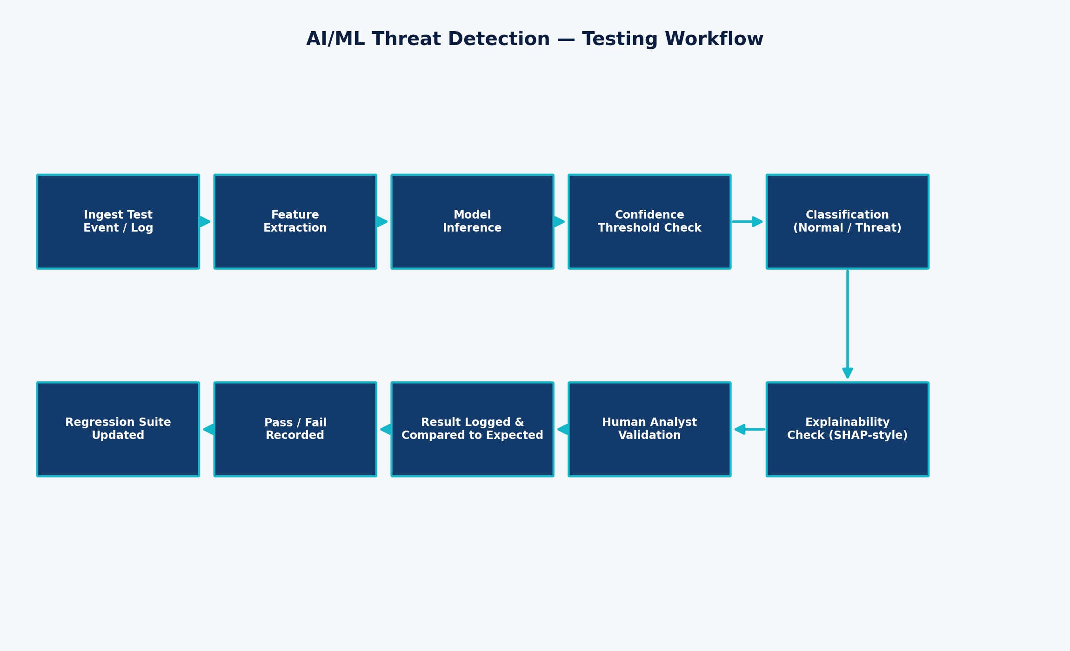
Figure 4: AI/ML Threat Detection Testing Workflow
Responsible AI Principle: Cybersecurity AI should not autonomously perform high-impact automated actions (e.g., isolating a Critical-tier production asset) without appropriate human-approval controls. This principle is directly tested in TC-AI-012.

14. Performance Testing
Performance test scenarios cover event-processing throughput, dashboard responsiveness under concurrency, and detection/alert latency. All numeric thresholds referenced (e.g., 10,000 events/minute, 20 concurrent sessions) are assumed test-design levels, clearly labelled as such, and not claimed system specifications.
Category | Scenario
Low / Normal / High event volume | TC-PERF-001
Sudden event spikes / scaling | TC-SCAL-001
Concurrent analysts | TC-PERF-002
Threat detection latency | TC-PERF-003
Alert generation latency | TC-PERF-004

15. Reliability and Recovery Testing
Category | Test Case(s)
Monitoring service failure | TC-REL-001
Sensor / agent failure | TC-RCV-001
Network interruption | TC-REL-003
Threat intelligence provider failure | TC-REL-002
Database / service failure and restart | TC-REL-004, TC-RCV-003
Recovery and event reconciliation | TC-RCV-002
Backup restoration | TC-REL-006, TC-RCV-004
Duplicate event handling | TC-REL-005
Business continuity for non-critical loss | TC-RCV-005

16. Usability Testing
Category | Test Case(s)
Dashboard readability | TC-USE-001
Search and filtering | TC-USE-002
Report generation workflow | TC-USE-003
Error message clarity | TC-USE-004

17. Test Data
The following representative, safe, simulated test data is used throughout this document. No real malware, real credentials, live exploit payloads, or instructions for attacking production systems are included.
Category | Example Test Data
Valid user credentials | admin_sec01 / Valid@Pass123 (test account)
Invalid credentials | admin_sec01 / WrongPass!1
Normal network events | 10.0.2.15 → 93.184.216.34:443 (benign HTTPS)
Suspicious events | Abnormal login from unfamiliar region + mass download
Malware simulation indicators | Labelled synthetic malware-behaviour profile (non-executable)
Phishing simulation indicators | Synthetic suspicious-domain metadata
Ransomware simulation indicators | Synthetic mass file-rename/encryption event pattern
Anomalous login events | Impossible-travel login pattern (test fixture)
Threat intelligence indicators | malicious-domain-test.example (test-only domain)
Invalid log records | Malformed JSON missing required fields
Duplicate events | Identical event resent from redundant agent
Boundary risk scores | 69 / 70 / 71 (assumed threshold = 70)

18. Traceability Matrix
The Requirement Traceability Matrix below maps each functional requirement to its associated test scenario(s) and detailed test case(s). Non-functional requirements are traced qualitatively throughout Sections 12–16 (Security, AI/ML, Performance, Reliability, Usability).
Req ID | Requirement (abridged) | Scenario ID(s) | Test Case ID(s) | Coverage Status
FR-01 | User authentication (username/password, MFA support) for all… | TS-01, TS-02, TS-03, TS-04, TS-65 | TC-AUTH-001, TC-AUTH-002, TC-BND-004, TC-BND-005, TC-SEC-006 | Covered
FR-02 | Role-based access control distinguishing Security Admin, Ana… | TS-06, TS-05, TS-68 | TC-AUTH-004, TC-SEC-001B, TC-SEC-001, TC-SEC-003 | Covered
FR-03 | Continuous monitoring of enterprise network traffic for susp… | TS-07 | TC-MON-001 | Covered
FR-04 | Continuous monitoring of endpoint devices (workstations, ser… | TS-08 | TC-MON-004 | Covered
FR-05 | Monitoring of cloud resources (storage, compute, IAM events)… | TS-09 | TC-MON-005 | Covered
FR-06 | Monitoring of user activity for policy violations and abnorm… | TS-10 | TC-MON-006 | Covered
FR-07 | Collection and normalization of security logs from heterogen… | TS-11, TS-14 | TC-MON-007, TC-MON-002 | Covered
FR-08 | Real-time processing of ingested security events with minima… | TS-07 | TC-MON-008, TC-BND-006, TC-PERF-001, TC-SCAL-001 | Covered
FR-09 | AI/ML-based detection of general security threats across mon… | TS-33, TS-41, TS-36 | TC-TD-001, TC-AI-001, TC-AI-010, TC-AI-012, TC-PERF-003 | Covered
FR-10 | Detection of malware signatures and malware-like behavior | — | — | Indirectly Covered (see related FR)
FR-11 | Detection of phishing attempts in email/web traffic indicato… | — | — | Indirectly Covered (see related FR)
FR-12 | Detection of ransomware behavior patterns (mass encryption, … | — | — | Indirectly Covered (see related FR)
FR-13 | Detection of insider-threat behavior through user behavioral… | — | — | Indirectly Covered (see related FR)
FR-14 | Statistical and ML-based anomaly detection across network an… | TS-34, TS-35, TS-36, TS-37, TS-38 | TC-AI-002, TC-AI-004, TC-AI-005, TC-AI-003, TC-AI-006, TC-AI-007 | Covered
FR-15 | Behavioral analysis correlating multi-source signals into a … | — | — | Indirectly Covered (see related FR)
FR-16 | Threat prediction using historical and streaming data trends | TS-40, TS-42 | TC-AI-009, TC-AI-011 | Covered
FR-17 | Ingestion of external threat intelligence feeds (indicators … | TS-25, TS-26 | TC-TI-001, TC-TI-002 | Covered
FR-18 | Correlation of internal events against ingested threat intel… | TS-29, TS-30, TS-32 | TC-TI-004, TC-TI-002B, TC-TI-005 | Covered
FR-19 | Risk scoring of detected events based on severity, asset cri… | TS-39, TS-67 | TC-BND-001, TC-BND-002, TC-BND-003, TC-SEC-008, TC-AI-008 | Covered
FR-20 | Automatic creation of security incidents from qualifying det… | TS-43, TS-not-applicable-invalid-transition | TC-INC-001, TC-INC-003 | Covered
FR-21 | Prioritization of incidents based on computed risk score and… | TS-44 | TC-INC-002 | Covered
FR-22 | Automated response actions (e.g., endpoint isolation, accoun… | TS-52, TS-55, TS-57 | TC-RESP-001, TC-RESP-002, TC-SEC-007 | Covered
FR-23 | Manual response actions initiated by a Security Analyst or I… | — | — | Indirectly Covered (see related FR)
FR-24 | Real-time dashboard visualization of security posture and ac… | TS-58, TS-65 | TC-DASH-001, TC-BND-007, TC-PERF-002, TC-USE-001 | Covered
FR-25 | Security analytics providing historical trend and pattern vi… | — | — | Indirectly Covered (see related FR)
FR-26 | Alert and notification generation to relevant stakeholders | TS-54, TS-58 | TC-PERF-004, TC-USE-004 | Covered
FR-27 | Incident investigation workspace with drill-down into eviden… | TS-67, TS-61 | TC-SEC-002, TC-USE-002 | Covered
FR-28 | Generation and export of security and compliance reports | TS-62 | TC-USE-003 | Covered
FR-29 | Audit logging of all system, analyst, and automated actions | TS-70 | TC-SEC-004 | Covered
FR-30 | Compliance monitoring support against configurable policy ba… | — | — | Indirectly Covered (see related FR)
FR-31 | Data integrity assurance for collected logs and generated in… | TS-69, TS-75 | TC-SEC-005, TC-REL-005, TC-RCV-002 | Covered
FR-32 | System recovery and state restoration after service interrup… | TS-73, TS-72, TS-71, TS-74, TS-76 | TC-REL-001, TC-REL-002, TC-REL-003, TC-REL-004, TC-REL-006, TC-RCV-001, TC-RCV-003, TC-RCV-004, TC-RCV-005 | Covered

19. Test Coverage Analysis
Coverage percentages are calculated directly from the mapping in Section 18 and the test-case categorization in Section 11. No coverage figure in this section is asserted without a corresponding traceable mapping.
Formula: Requirement Coverage % = (Requirements mapped to ≥ 1 test case / Total testable FRs) × 100 = (24 / 32) × 100 = 75.0%
Coverage Dimension | Result
Functional requirement coverage | 24 / 32 FRs directly mapped (75.0%); remaining FRs are indirectly exercised through related requirement test cases
Non-functional requirement coverage | 20 / 20 NFRs addressed across Sections 12–16 and the NFR table (100% qualitative coverage)
Test scenario coverage | 76 scenarios defined; 70 scenarios directly instantiated as detailed test cases
Positive test coverage | 16 functional (positive-path) test cases
Negative test coverage | 10 negative test cases
Boundary test coverage | 7 boundary test cases across 4 boundary fields
Security test coverage | 8 dedicated security test cases
AI/ML test coverage | 9 dedicated AI/ML test cases
Reliability test coverage | 6 dedicated reliability test cases (plus 5 recovery test cases)

20. Risk-Based Testing
Critical cybersecurity functionality — particularly threat detection accuracy and automated response correctness — receives the highest testing priority, since failures here directly translate into missed breaches or incorrect high-impact automated actions.
Risk | Classification | Related Test Case(s)
Missed cyber threats (false negative) | Critical | TC-AI-005
Incorrect automated response execution | Critical | TC-RESP-001, TC-AI-012
Unauthorized access / privilege escalation | Critical | TC-SEC-001, TC-SEC-003
AI model unavailable during active monitoring | High | TC-AI-006
Data loss during outage | High | TC-REL-004, TC-RCV-002
Incorrect risk classification | High | TC-BND-002, TC-INC-002
Threat intelligence feed failure | Medium | TC-TI-002B, TC-REL-002
Monitoring/sensor failure | Medium | TC-RCV-001
Usability friction during investigation | Low | TC-USE-002, TC-USE-003

21. Defect Severity and Priority

Severity Levels
Severity | CyberShield 360 Example
Critical | AI engine fails to detect a high-confidence ransomware pattern (false negative on Critical asset)
High | Automated endpoint isolation does not execute for a confirmed malware incident
Medium | Threat intelligence feed conflict is silently resolved instead of flagged for review
Low | Dashboard severity icon color is inconsistent with the legend

Priority Levels
Priority | CyberShield 360 Example
P1 | Unauthorized privilege escalation succeeds (must fix immediately)
P2 | Incident state machine allows an invalid transition (Closed → Investigating)
P3 | Dashboard refresh exceeds the assumed latency window under concurrent load
P4 | Report export formatting is misaligned

22. Entry and Exit Criteria

Entry Criteria
- Requirements (FR/NFR) are finalized and reviewed
- Test environment (monitoring agents, AI/ML engine stub, threat-intel connector) is available
- Test data (Section 17) is prepared
- Monitoring components are configured for the test environment
- Test build is deployed to the test environment

Exit Criteria
- All Critical- and High-priority test cases are executed
- No unresolved Critical-severity defects remain open
- High-risk functionality (Section 20) has been validated
- Requirement coverage targets (Section 19) are achieved
- All dedicated security test cases (Section 12) are completed
- Regression testing of previously passed test cases is completed
Note: Specific numeric exit thresholds (e.g., “95% pass rate”) are not asserted here, as this is a proposed criteria set for a system that has not yet been executed; any such thresholds should be agreed upon and documented before execution begins.

23. Test Environment
The following test environment is assumed for execution purposes; implementation-specific items are explicitly labelled as assumptions.
Component | Description (Assumption where noted)
Application environment | Isolated staging deployment of CyberShield 360 (assumption)
Monitoring agents | Test-mode agents deployed on representative endpoints
Log sources | Synthetic firewall, endpoint, and cloud log generators
Threat intelligence source | Mock/test threat-intelligence feed with controlled indicators
AI/ML detection engine | Test instance with a labelled evaluation dataset (assumption)
Database | Isolated test data store (assumption: not shared with production)
Dashboard | Test-environment analyst dashboard
Network environment | Segmented test network isolated from production enterprise traffic
Test endpoints | Representative Windows/Linux test endpoints
Test accounts | Dedicated non-production accounts for each actor role (Section 5)

24. Sample Defect Reports
Important: The defect reports below are hypothetical / illustrative examples showing how defects would be recorded during actual execution. They do not represent real defects found in an executed system.

Sample Defect: DEF-001 (sample/hypothetical) — Invalid incident state transition not rejected
Field | Value
Defect ID | DEF-001 (sample/hypothetical)
Title | Invalid incident state transition not rejected
Requirement ID | FR-20
Test Case ID | TC-INC-003
Severity | Medium
Priority | P2
Environment | Test/Staging
Steps to Reproduce | 1. Set incident to Closed. 2. Attempt transition to Investigating via API.
Expected Result | Transition rejected; incident remains Closed.
Actual Result | Transition hypothetically succeeds, corrupting incident history (illustrative only).
Status | Sample — New

Sample Defect: DEF-002 (sample/hypothetical) — Automated response executes on Critical asset without approval
Field | Value
Defect ID | DEF-002 (sample/hypothetical)
Title | Automated response executes on Critical asset without approval
Requirement ID | FR-22
Test Case ID | TC-AI-012
Severity | Critical
Priority | P1
Environment | Test/Staging
Steps to Reproduce | 1. Trigger qualifying detection on a Critical-tier server. 2. Observe response engine behaviour.
Expected Result | System requests human approval before isolating a Critical-tier asset.
Actual Result | System hypothetically isolates the asset automatically without approval (illustrative only).
Status | Sample — New

Sample Defect: DEF-003 (sample/hypothetical) — Sensitive log field visible to low-privilege role
Field | Value
Defect ID | DEF-003 (sample/hypothetical)
Title | Sensitive log field visible to low-privilege role
Requirement ID | FR-31
Test Case ID | TC-SEC-005
Severity | High
Priority | P2
Environment | Test/Staging
Steps to Reproduce | 1. Log in as Enterprise User. 2. Query raw log store containing session tokens.
Expected Result | Sensitive fields masked for this role.
Actual Result | Sensitive fields hypothetically shown unmasked (illustrative only).
Status | Sample — New

25. Test Execution Summary
As this is a test-design deliverable, the system has not been executed against these test cases. The template below is provided for use once execution begins.
Metric | Value
Total Test Cases | 70
Executed | 0
Passed | 0
Failed | 0
Blocked | 0
Not Executed | 70
Pass Percentage | Not Applicable (0 executed)
Fail Percentage | Not Applicable (0 executed)

26. Ethics and Responsible AI
This section directly addresses the CO4 emphasis on security, reliability, and ethics as applied to CyberShield 360's AI-driven automation.
- Responsible cybersecurity automation: high-impact automated actions on Critical-tier assets require human approval (TC-AI-012)
- Human oversight: analysts retain the ability to review, override, and audit automated decisions
- Avoiding harmful automated actions: partial/failed automated responses escalate to a human rather than retrying blindly (TC-RESP-002)
- Privacy and data minimization: user-activity monitoring should collect only what is necessary for security purposes (NFR-12)
- Bias in AI models: detection behaviour should be evaluated for consistency across user groups and asset types (NFR-16)
- Explainability: high-severity predictions must provide an interpretable rationale (TC-AI-009)
- False positives and false negatives: both are explicitly tested and tracked, not ignored (TC-AI-004, TC-AI-005)
- Accountability and auditability: every automated and manual action is logged with actor, timestamp, and outcome (TC-SEC-004)
- Secure handling of security logs: sensitive fields are access-restricted (TC-SEC-005)
- Protection of sensitive user information: consistent with data-minimization and confidentiality principles above

27. Quality Assurance and DevOps Connection
The CyberShield 360 testing strategy fits into a DevSecOps lifecycle as follows:
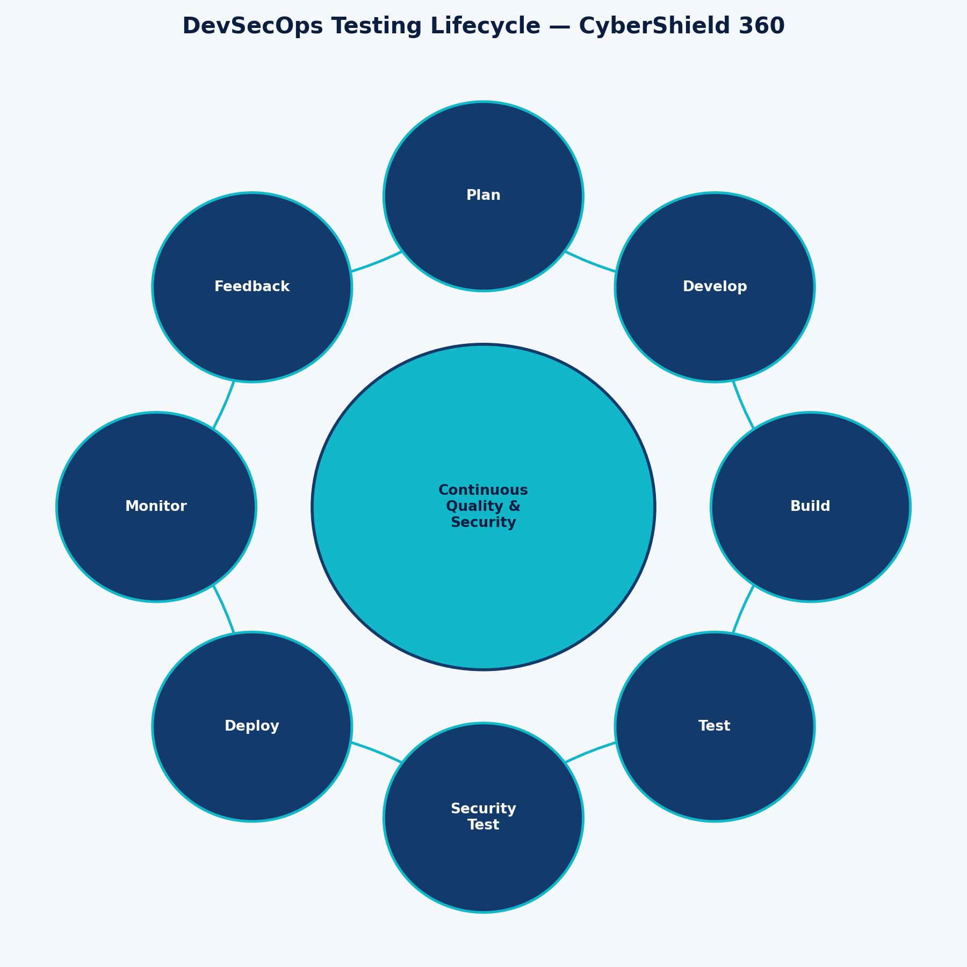
Figure 5: DevSecOps Testing Lifecycle for CyberShield 360
- Automated testing: unit and integration tests run on every code change (CI)
- Regression testing: previously passed test cases re-run automatically before each release
- CI/CD quality gates: builds are blocked from promotion if Critical/High test cases fail
- Security testing: SAST/DAST-style checks integrated alongside functional test suites
- Monitoring: production telemetry feeds back into detection-rule and model refinement
- Continuous feedback: defect and false-positive/negative data inform backlog prioritization
- Model validation: AI/ML models are evaluated against a held-out labelled dataset before promotion
- Model deployment controls: staged/rolling rollout (as tested in TC-AI-010)
- Rollback: a prior model or build version can be restored if regressions are detected

28. Conclusion
This document has presented a comprehensive test strategy and detailed test case design for CyberShield 360, covering functional correctness across 32 functional requirements, quality attributes across 20 non-functional requirements, and 70 detailed test cases spanning positive, negative, boundary, security, AI/ML, performance, reliability, usability, and recovery conditions.
The proposed test suite validates the system's ability to reliably detect, correlate, prioritize, and respond to security threats through its AI/ML detection engine and threat-intelligence integration, while ensuring that automated incident response, dashboard reporting, and compliance-support functionality behave correctly under both normal and adverse conditions.
Explicit attention to AI explainability, bias considerations, false-positive/false-negative tracking, and human-approval controls for high-impact automated actions demonstrates responsible AI practice. Combined with reliability, recovery, and business-continuity testing, this test suite directly satisfies CO4: the implementation of robust testing, quality assurance, and DevOps practices emphasizing security, reliability, and ethics.

29. References
- ISTQB. Foundation Level Syllabus — core software testing principles and terminology.
- IEEE. IEEE 829 — Standard for Software and System Test Documentation.
- NIST. Cybersecurity Framework — general guidance on cybersecurity risk management.
- OWASP. OWASP Testing Guide — general guidance on web application security testing.
- General DevSecOps principles integrating security testing into the CI/CD pipeline.

Note: This document does not fabricate specific publication years, authors, or URLs for the above references; students should verify and cite current editions per their institution's citation requirements.

30. Appendices

Appendix A — Traceability Flow
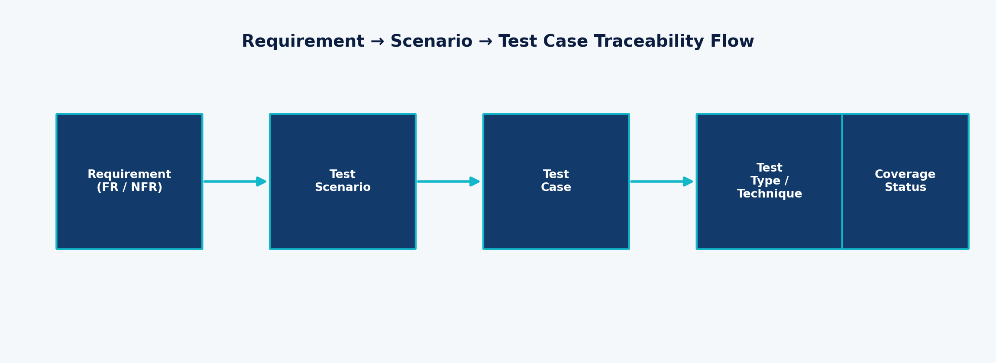
Figure 6: Requirement → Scenario → Test Case → Test Type Traceability Flow

Appendix B — Glossary of Abbreviations
Abbreviation | Meaning
FR | Functional Requirement
NFR | Non-Functional Requirement
TS | Test Scenario
TC | Test Case
AI/ML | Artificial Intelligence / Machine Learning
TI | Threat Intelligence
RBAC | Role-Based Access Control
SLA | Service Level Agreement
CO | Course Outcome
DevSecOps | Development, Security, and Operations

